Title (FROM HANDCRAFTED TO AUTOMATED DEEPLEARINING AND COMPUTER VISION)
Proposed Structure of the Research Paper
- Abstract

- Introduction
According to UNESCO: “For centuries, many populations have been associated with the date palm tree, which has aided them in the construction of their civilizations in arid regions [1].
Representing prosperity, heritage, and sustainability, Date palms are vital agricultural and cultural resources in Saudi Arabia. They contribute significantly to food security, the industrial sector in production, trade, and the national economy [2].
However, many people, especially small-scale palm owners, such as households and community centers, often lack the required expertise and knowledge for proper tree care, pest management, and disease diagnosis. Where there’s a gradual decline of traditional farming knowledge, usually held by older farmers, has made it difficult for new generations to access reliable guidance. This situation risks not only lower productivity and higher economic losses but also the erosion of cultural practices tied to palm cultivation [3].
To address this challenge, the project proposes a mobile application for palm care and disease, and pest identification. It utilizes computer vision, artificial intelligence and other technologies for palm disease and pest diagnosis, offers seasonal fertilizing and irrigation reminders, and includes a mini-wiki for knowledge acquisition. It also connects palm owners to agricultural experts through a consultation platform to offer safe advice while allowing experts to exchange their knowledge. By providing a useful, easy to access, and applicable solution, the project helps improve palm management and preservation of agricultural heritage for small-scale owners. In this report, problem background, project objectives, methodology, system design, implementation, and testing are outlined, followed by major findings, limitations, and recommendations for further work.

- Literature Review: Methodological Approaches
- Background
The Saudi date palm industry faces a critical generational knowledge gap, where the loss of traditional expertise has left new growers unable to effectively identify and manage leaf-based diseases. The agricultural and economic damage results from the inability to diagnose leaf-related issues. The Nekhlawi project addresses this by digitizing expert knowledge through an AI-powered platform for automated palm leaf detection. The project establishes a digital link for accurate leaf disease diagnosis through its shift from traditional machine learning methods to operational deep learning systems which support both economic stability and cultural heritage protection.
- Comprehensive Analysis of Detection and Classification Approaches
The methods for palm leaf disease identification and classification have progressed from manual feature extraction to automatic deep learning system development. The first studies used standard image processing methods to obtain pre-defined features from leaf surfaces through color thresholding and K-means clustering and texture analysis using GLCM and LBP methods. The diagnostic indicators were analyzed through the application of conventional machine learning techniques which included Support Vector Machine and Random Forest and K Nearest Neighbor methods. The methods demonstrated success with small datasets but they encountered challenges when handling leaf surfaces that exhibited different lighting conditions and intricate background patterns. Deep Learning methods which use Convolutional Neural Networks (CNNs) to extract features from leaf images are now the most effective solution to these current system limitations. The current advanced systems which include VGG, ResNet ,DenseNet and Inception have achieved excellent accuracy when identifying multiple types of leaf infections. The Modified Resididual Network (MResNet) achieved 100% validation accuracy in identifying specific symptoms like brown spots and white scale [10] and MobileNet architectures reached 99.56% accuracy in distinguishing between bacterial leaf blight and leaf smut [9]. The implementation of CNN-SVM hybrid models has successfully improved disease stage classification accuracy which reached 98.29% [12, 19].
- Dataset Creation, Preprocessing, Augmentation
Reliable palm leaf diagnostic tests depend on high-quality datasets as their essential foundation. Data collection uses smartphones and DSLR cameras to capture actual symptoms which result from fungal and pest-related disorders under different natural lighting conditions [25]. The model achieves its target accuracy because preprocessing methods use image normalization together with resizing to remove both noise and lighting interference [10, 19].
The researchers use data augmentation methods to create additional dataset content while protecting their model from overfitting problems. The researchers create field environment simulation through data transformations which include flipping, rotation, brightness adjustment, and color jittering effects [10, 27]. The process leads to major performance improvements because models achieve 100% accuracy after training with multiple augmented visual inputs [10].
- Problem Statement
Date palms are one of the most important crops in Saudi Arabia and the Gulf region, not only as a source of food and income, but also as a symbol of cultural identity and heritage. Evidence indicates that date palms have been present in the region since around 4000 BC. [4] Today, they play a pivotal role in national and regional economies through local consumption, exports, and tourism events such as date festivals. According to the National Center for Palms and Dates, Kingdom's date exports in 2024 amounted to more than 1.695 billion Saudi riyals [5].
Despite this importance, date palm owners, especially small farmers and home growers face ongoing challenges in managing their trees effectively. Date palm cultivation is surrounded by a wide range of threats. Palm trees face major challenges, the most important of which are pests and diseases that significantly impact palm production in the region, which, if left untreated, lead to reduced production, tree death, and economic losses equivalent to 28% of total production [6]. These threats include insect pests, fungal infections, and nutrient deficiencies. These problems are exacerbated by dy in the Al-Ahsa Oasis revealed that most farmers were over 40 years old, and their knowledge risks being lost in the absence of proper documentation or digital transfer mechanisms (see Figure 1) [7].
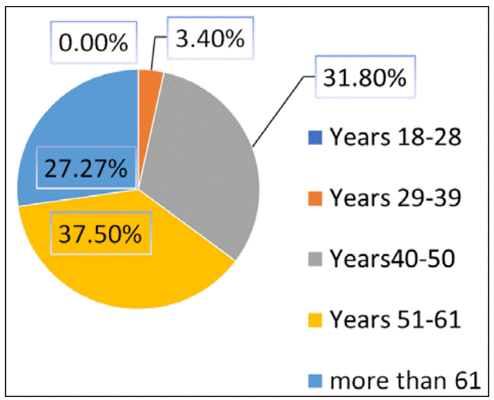
Figure 1: Age of palm farmers in Al-Ahsa Oasis
Current digital solutions in the Arab world remain limited and fragmented, primarily designed for large farms or government monitoring initiatives. Studies show that Arab agricultural applications are relatively few compared to their global counterparts, and that older or less educated farmers often struggle to adopt mobile technologies, facing barriers in language, ease of use, and digital literacy [8]. As a result, smallholders and inexperienced palm owners remain underserved and lack easy-to-use and accessible tools that meet their daily needs.
The absence of comprehensive digital platforms adapted to the Gulf countries widens this gap. Without interventions that combine modern diagnostic tools, practical guidance, and mechanisms for preserving specialized knowledge, the region risks losing agricultural competencies over time. This unresolved problem highlights the urgent need for solutions that link technological accessibility with agricultural sustainability.

- Proposed Nekhlawi Framework
Framework Overview
  - High-level architecture of the Nekhlawi system
    - The high-level framework of Nekhlawi system, as shown in Overview Diagram (Figure 1) follows a layered structure consist of user interface and expert interaction, artificial intelligence, and Palm Care Hub to facilitate disease diagnosis and professional consultation:

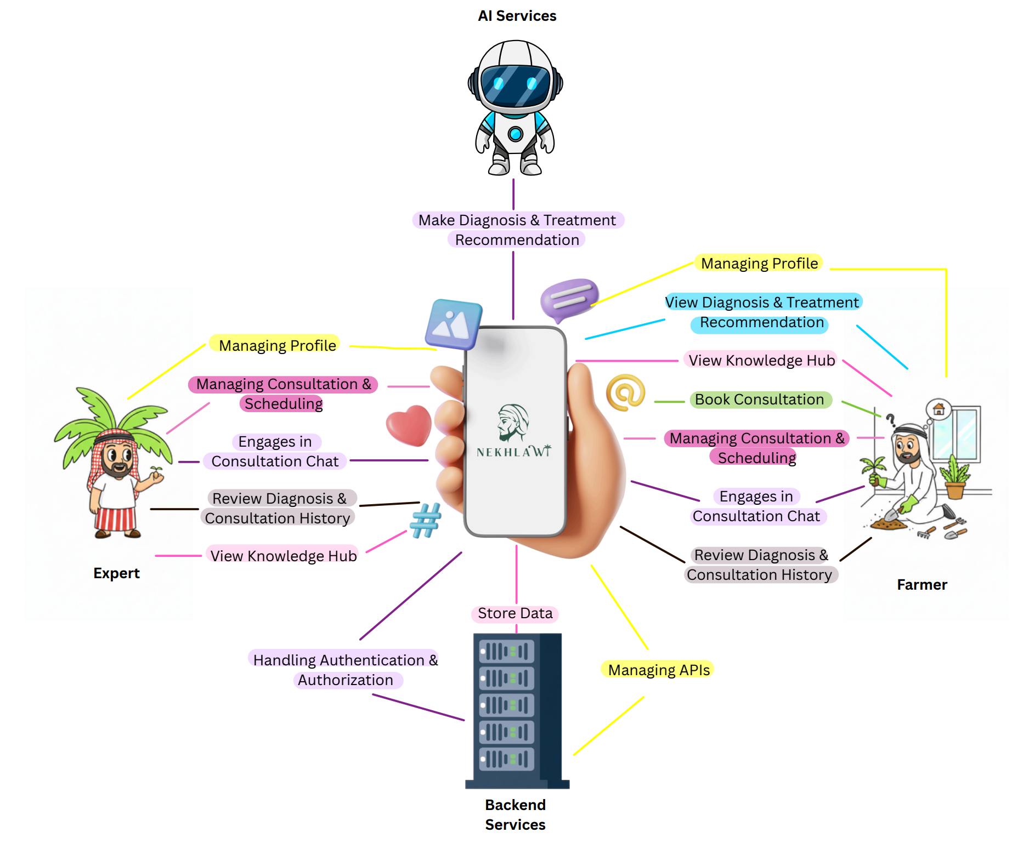
Figure 2: Overview Diagram
  - The following will describe the operational layers of Nekhlawi:
    - User Interface Layer: this layer consists of two classes of users:
      - Palm Owners use the application to upload images within AI diagnosis and treatment tool, book consultation sessions, view past AI diagnosis and treatment, and previous consultations.

      - Agricultural Experts interact with interfaces to manage their consultation schedules, review their client requests, and provide real time guidance.
    - Intelligence Layer: : this layer is the “heart” of Nekhlawi application, it will apply deep learning models and image processing to analyze uploaded images of palm leaves or trunks to detect pets (Brown spots, White spots, Fusarium Wilt) and diseases. If the AI model detects the issue with high confidence (typically >= 60%), it will generate a diagnosis and treatment recommendations.
    - Knowledge Layer: ): this will provide a digital bridge between traditional farming and modern technology.

    - Expert Interaction Layer: this layer will facilitate the connection between users and expert:
      - Real time communication: supporting chat, video calls, voice notes.
      - Scheduling and billing: Handling the appointments, verifying expert availability.

  - Mobile application architecture
The architecture of the Nekhlawi mobile application is based on a client–server architecture, where the mobile client handles tasks such as user interactions and image capturing, representing the front-end of the app, while the backend server handles image processing, authentication, and other tasks. This is combined with a layered structure, ensuring security and scalability.
    - Mobile Application Components

1. Mobile Client
This represents the front-end part of the application, implemented using three layers:
- Presentation layer: user interface, which is responsible for managing interactions between the user and the application
- Business Logic layer: acts as a linking layer between the Presentation and Data layers to manage data flow and enforce business rules
- Data layer: manages data and communication with external components
However, the responsibilities of the mobile client include:
- Providing a user interface
- Capturing and gathering images through the device camera or gallery
- Sending images to the backend
- Displaying disease detection results, confidence levels, and treatment recommendations
- Connecting users with experts for consultations

2. Backend Server
The server is the central processing component; it is the coordination layer of the application and is responsible for communicating with AI services, managing APIs and data flow, and handling authentication and authorization.

3. AI Services
This component hosts the AI model used and may be deployed as a cloud-based service. The services extract features from captured images to detect diseases and provide treatment recommendations using machine learning, and then return the results to the backend server.

4. Database
The required data stored in this layer include:
- User information
- Historical consultation records
- Mini-wiki articles
- AI service results
1.2. Architectural Benefits
The clear separation of each layer eases the maintenance of the application and provides secure communication and controlled access. Cloud-based services allow the application to perform faster and reduce the load on mobile devices; moreover, they allow the application to be scalable. Lastly, having a simple user interface boosts usability.

  - Integration of AI, ML, image processing, and backend services
The application aims to achieve an efficient and accurate disease detection and diagnosis; thus, it integrates several technologies. After using image processing techniques to resize the image and enhance its overall quality, the machine learning model is designed to detect diseases using a CNN-based classifier. AI services will recommend treatment based on the machine learning model results, while backend services and databases store the results, other related data, and user information to provide authorization and authentication services.

  - Data flow between components
Input: The process of diagnosis begins with the user either uploading an image of the palm from their phone gallery or by capturing a live image of the palm through the app’s interface.
Processing: After acquiring the image from the user, the cloud based model will process it by applying preprocessing techniques and then applying the analysis.
Output: after processing and according to accuracy and confidence level threshold, the output will be displayed as interpretation or diagnosis in the app to the user.
Storage and retrieval: each diagnosis made, along with user profiles and consultation logs will be automatically saved in the backend storage system and ready to be retrieved from the user.
Expert feedback: if the processing didn’t meet the threshold of confidence level, the user will be transitioned to seek professional help from an expert which can share images with to get human validation.

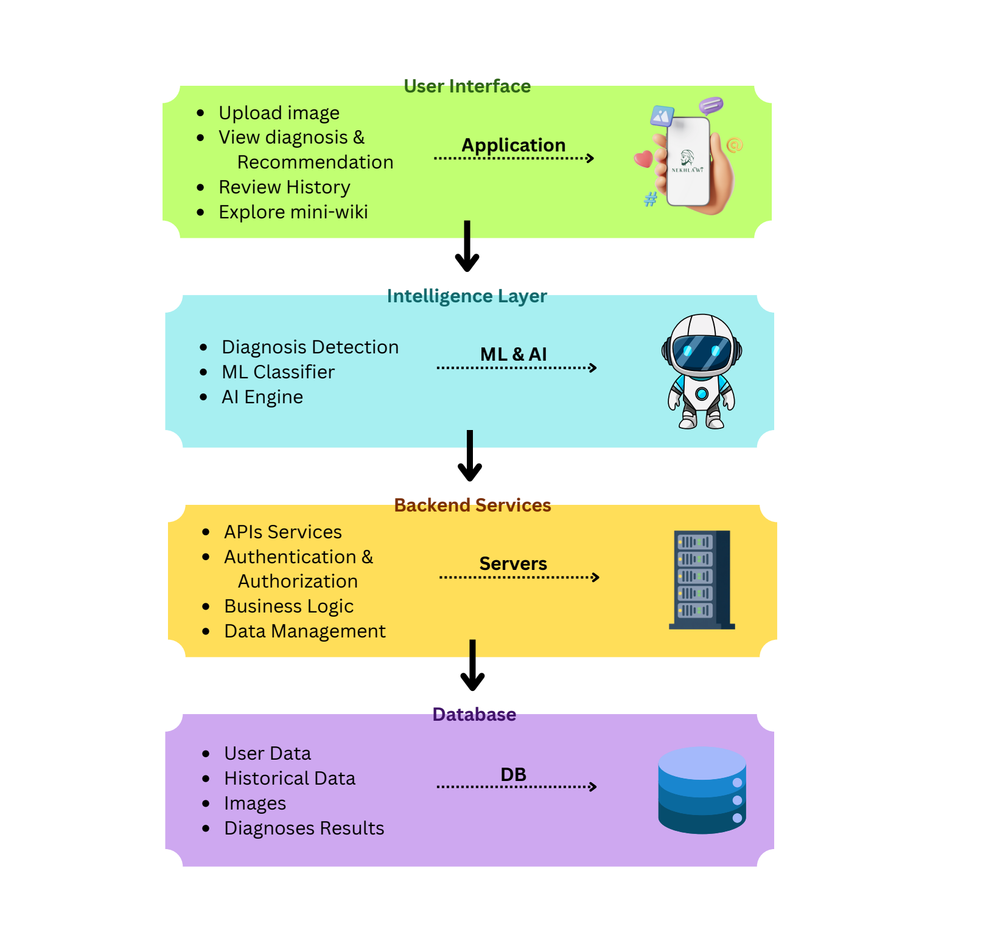
Figure 3: Data Flow Diagram

  - Image Scanning and Diagnosis Module
The system will acquire images easily from the user either by uploading it from their mobile device or capturing a real time image by the device’s camera. After acquiring the image, the model will subject it to image preprocessing techniques like Morphological Analysis for noise reduction and structural refinement and then start to perform image processing.The model is trained with a labeled data set that was subject to preprocessing techniques like normalization, resizing and enhancement. What is considered as an intelligence layer will utilize supervised machine learning and computer vision trained on infected and healthy date palm tree leaves, the model is designed to diagnose diseases like () and target to reach an output with an accuracy of at least 90%, the output should reach a confidence level of (>=60%) as a threshold to start the interpretation process and display it to the user as a diagnosis, however if the output has a level of confidence of (<60%) the user will be informed of that and will be suggested to seek professional help by a real expert.

- Discussion
The given Nekhlawi framework is a holistic and feasible answer to the issue of small date palm owners in Saudi Arabia and the Gulf region. The framework also aligns with the emerging research trend in which researchers focus on early detection, accessibility, and decision support in the agricultural systems by integrating the use of computational intelligence, image processing, and expert knowledge into a single mobile-based platform.

The capacity to assist in the early identification of palm diseases and pests is one of the major advantages of the Nekhlawi framework since it is indispensable in minimizing the loss of yield and ensuring the irreparation of trees. The research into the field of computational intelligence-based agricultural diagnosis has revealed that the effective rate of the treatment is highly improved and the economic effects diminished by early detection of the issue. Nekhlawi lets users detect diseases earlier than they can see symptoms in any serious way through the use of CNN-based models that are trained on known palm images, which is a significant shortcoming of traditional farming practices, which may be based on late visual inspection.

The other valuable input of the framework is that it automates expert-level diagnostic processes. Conventional diagnosis of diseases relies a lot on the availability of experienced farmers or agricultural experts, who are not very numerous, and their knowledge is usually not documented. Nekhlawi is converting this knowledge into digital form by analyzing it using AI and creating a knowledge layer comprising treatment suggestions and learning materials. This helps in the preservation and transfer of knowledge, especially when the older generations of farmers retire, which has been a major topic of debate in literature on agricultural sustainability.

Confidence-based decision thresholds are also integrated, which increases the credibility of the system. With the framework, the possibility of misinformation and wrong treatment is minimized by simply showing AI-generated diagnoses with confidence rates above a specific level (≥60%). With low confidence, the users are directed to experts. consultation so that the human expertise does not leave the decision-making loop. This human-AI solution is based on the best practices that have been reported in intelligent diagnosis systems, where AI is applied to support but not to substitute experts.

The mobile-first and layered design of Nekhlawi, with regard to usability, enables more ordinary users, including home growers and smallholders, to be more accessible. In contrast to current digital agricultural tools, which are mainly used in large farms or institutional monitoring, Nekhlawi is aimed to be simple, user-friendly, and applicable to day-to-day palm care practices. Image capture, history of diagnoses, seasonal reminders, and mini-wiki articles, among others, provide a reduced technical barrier to adoption and promote regular user participation.

Altogether, the Nekhlawi framework, being implemented, could enhance palm health management, decrease losses of the economies, save agricultural traditions, and empower small palm owners with the help of technology-oriented mentoring. The framework fills the gap between the traditional knowledge and modern computational intelligence, which will serve sustainable agriculture.

- Conclusion
- References

